

**Experiment No.:7**

| **TITLE:** Study Cisco Switch Router Configuration Command using Cisco packet tracer |
| --- |

**_____________________________________________________________________________**

**AIM:** To study basic Cisco Switch & Router configuration Commands and configure

1. Virtual LAN (VLAN).

**Expected Outcome of Experiment:**

**CO:**

**Books/ Journals/ Websites referred:**

1. S. Tanenbaum, “Computer Networks”, Pearson Education, Fourth Edition
2. Forouzan, “Data Communications and Networking”, TMH, Fourth Edition

_____________________________________________________________________________

**Pre Lab/ Prior Concepts:**  Basics of Routing and Cisco Packet Tracer

**_____________________________________________________________________________**

**New Concepts to be learned:** Different Modes of Operation of Cisco router

**Cisco IOS Modes of Operation:**

* The Cisco IOS software provides access to several different command modes. Each command mode provides a different group of related commands.
* For security purposes, the Cisco IOS software provides two levels of access to commands:
  + User mode
  + Privileged mode
* The unprivileged user mode is called user EXEC mode. The privileged mode is called privileged EXEC mode and requires a password. The commands available in user EXEC mode are a subset of the commands available in privileged EXEC mode.
* The following table describes some of the most commonly used modes, how to enter the modes, and the resulting prompts. The prompt helps you identify which mode you are in and, therefore, which commands are available to you

| **Modes of Operation** | **Usage** | **How to enter the mode** | **Prompt** |
| --- | --- | --- | --- |
| **User EXEC** | Change terminal settings on a temporary basis, perform basic tests, and list system information. | First level accessed. | Router> |
| **Privileged EXEC** | System administration, set operating parameters. | From user EXEC mode, enter enable password command | Router# |
| **Global Config** | Modify configuration that affect the system as a whole. | From privileged EXEC, enter configure terminal. | Router(config)# |
| **Interface Config** | Modify the operation of an interface. | From global mode, enter interface type number. | Router(config-if)# |
| **Setup** | Create the initial configuration. | From privileged EXEC mode, enter command setup. | Prompted dialog |

**User EXEC Mode:**

When you are connected to the router, you are started in user EXEC mode. The user EXEC commands are a subset of the privileged EXEC commands.

**Privileged EXEC Mode:**

Privileged commands include the following:

• Configure – Changes the software configuration.

• Debug – Display process and hardware event messages.

• Setup – Enter configuration information at the prompts.

Enter the command disable to exit from the privileged EXEC mode and return to user EXEC mode.

**Configuration Mode:**

Configuration mode has a set of sub-modes that you use for modifying interface settings, routing protocol settings, line settings, and so forth. Use caution with configuration mode because all changes you enter take effect immediately.

To enter configuration mode, enter the command configure terminal and exit by pressing Ctrl-Z.

**Note:** Almost every configuration command also has a no form. In general, use the no form to disable a feature or function. Use the command without the keyword no to re-enable a disabled feature or to enable a feature that is disabled by default. For example, IP routing is enabled by default. To disable IP routing, enter the no IP routing command and enter IP routing to re-enable it.

1. **Virtual LAN (VLAN):**

A virtual local area network (VLAN) is a LAN which is not configured by physical wiring but it is configured by software. A VLAN is logical group of network devices that appear to be on same LAN despite their geographical distribution. A VLAN is implemented so that network administrators can connect a group of host in the same domain inspite of their physical location to achieve scalability and improve security features.

To subdivide a network into virtual LANs, one configures a network switch or router. Simpler network devices can partition only per physical port (if at all) , in which case each VLAN is connected with a dedicated network cable ( and VLAN connectivity is limited by the number of hardware ports available) More sophisticated devices can mark packets through tagging, so that a single interconnect ( trunk) may be used to transport data for multiple VLANs. VLAN can greatly simplify network design and deployment, because VLAN membership can be configured through software.

**Stepwise-Procedure:**

1. **Creating a simple LAN network using packet tracer:**

**Step 1:** Select 12 PCs from the end devices and one fast ethernet switch (2950/24 ports)

**Step 2:** Connect PCs and switch via copper cable from the panel. Connection can be verified by appearance of all green dots on the links.

**Step 3:** For PCs to communicate click on PC0.

* Dialog box for PC0 appears.
* Click on desktop applications by packet tracer.
* Go to IP configuration.
* Enter IP address to identify host i.e., PC0 (for example: 192.168.1.1)
* Subnet mask-by default already set one can change it as per his/her specification.

**Step 4:** Repeat step 3 for PC1

**Step 5:** Ping the PCs and check their working status.

**Step 6:** Simple PDU (Protocol Data Unit) to simulate network traffic by sending ICMP PDU to assess the network traffic. View simulation in simulation mode

**Step 7:** Configure two VLAN in a switch in 6 verticals.

**Step 8:** As per design, assign membership of VLAN to port using following command.

# switch port access vlan2 or vlan3

**Step 9:** Check the status of VLAN.

1. **Static Routing Configuration**

**IMPLEMENTATION:** (printout of code)

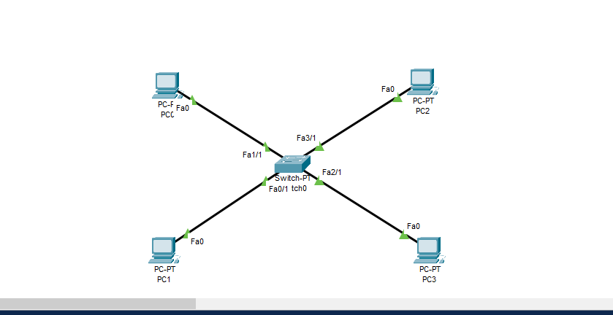

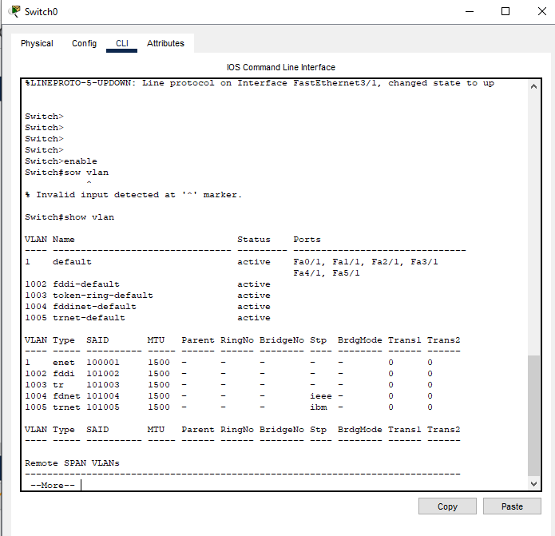

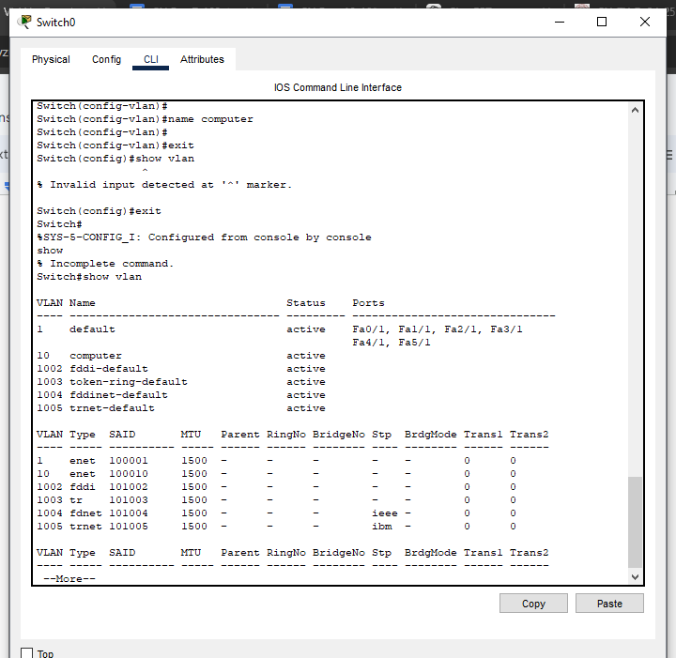

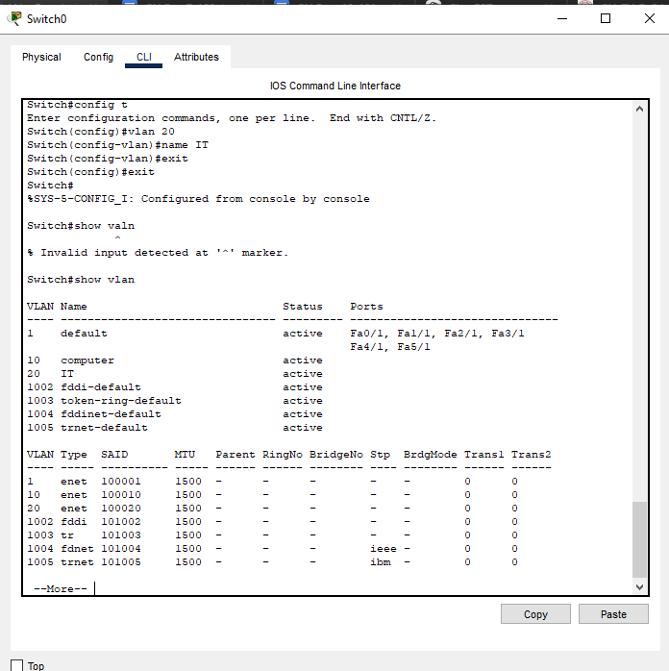

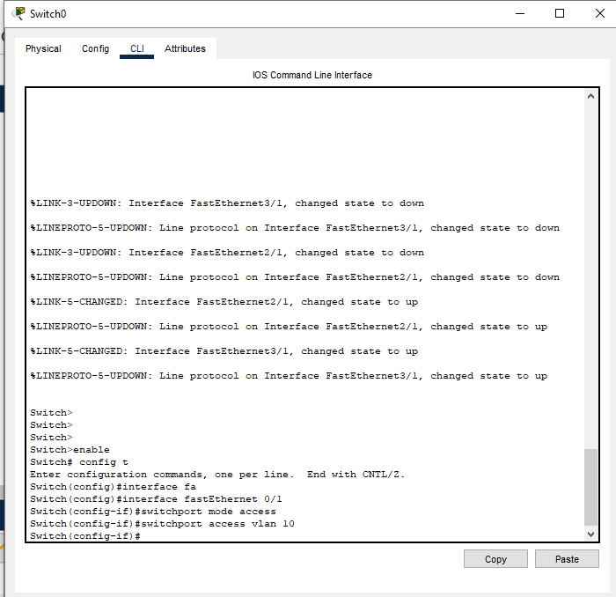

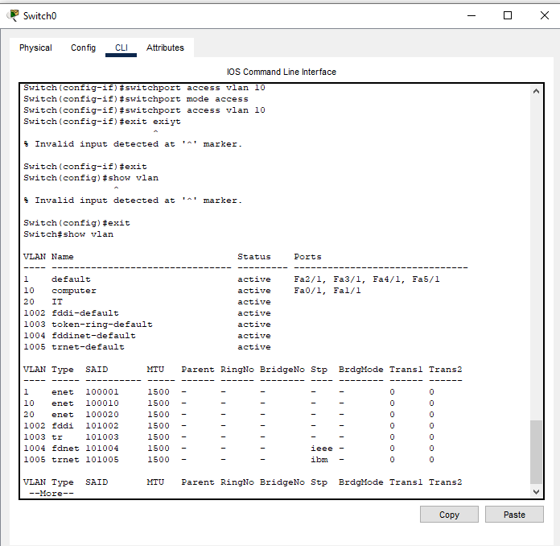

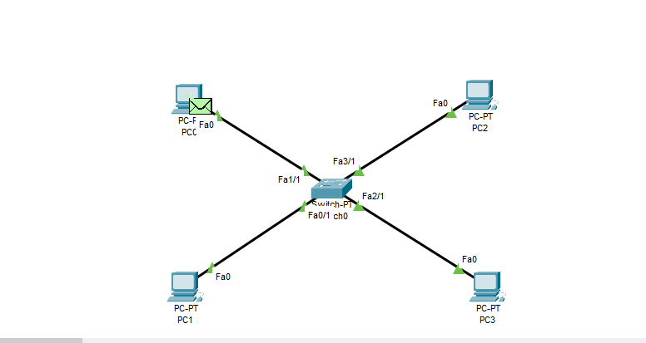

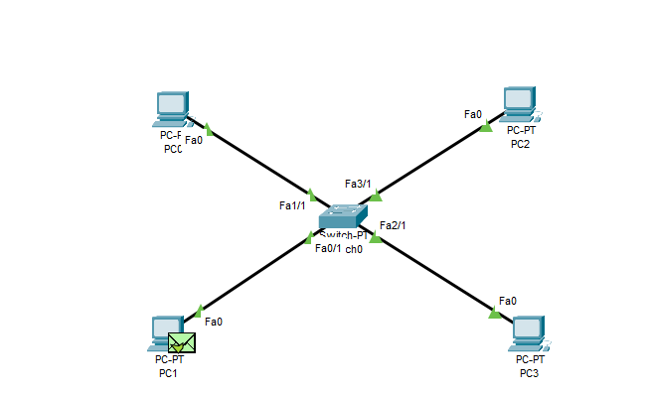

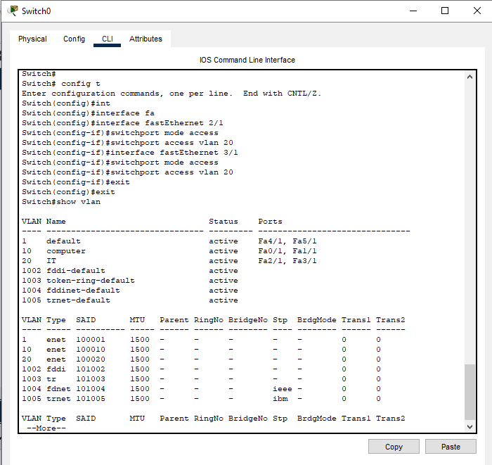

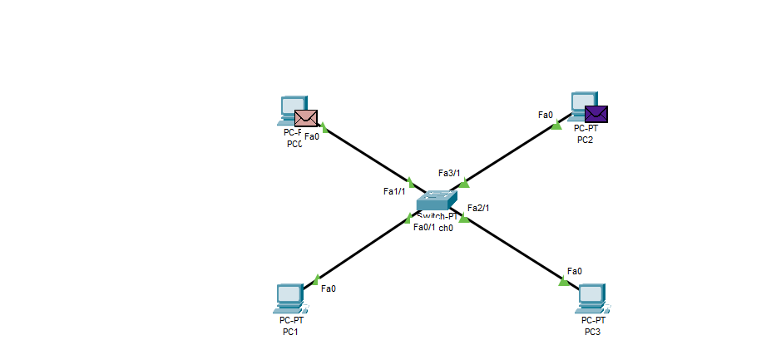

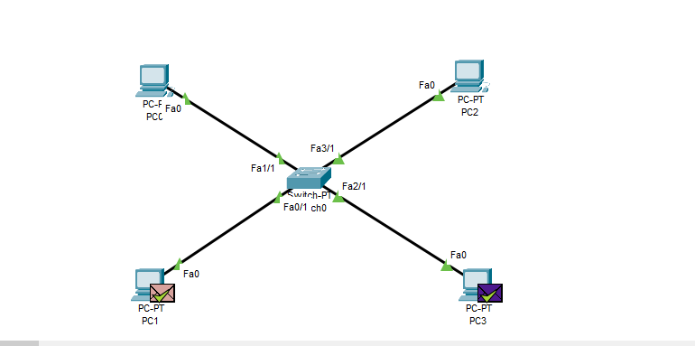

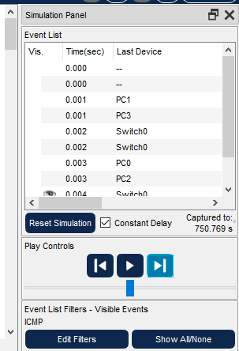

6 pcs

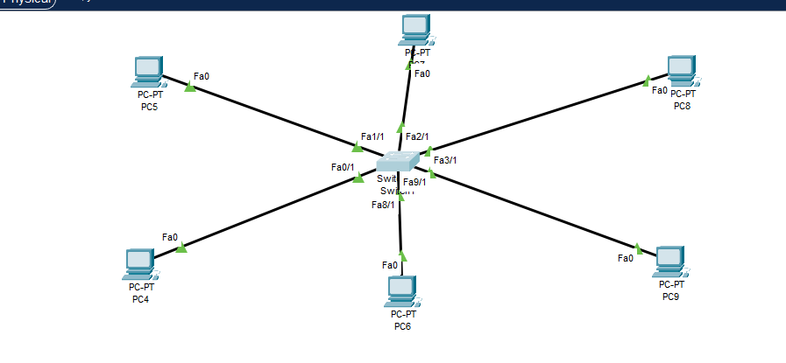

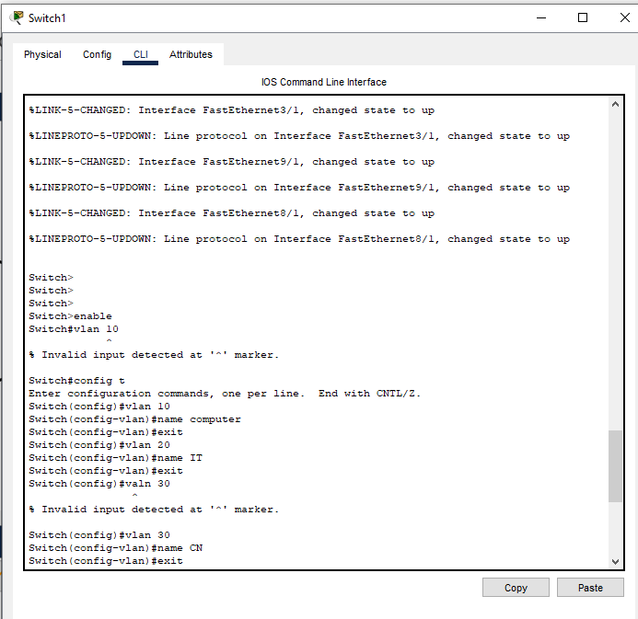

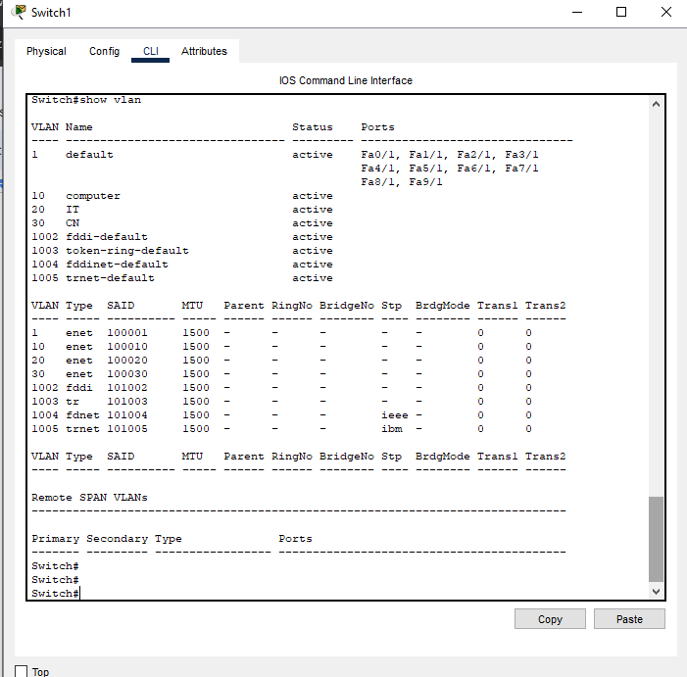

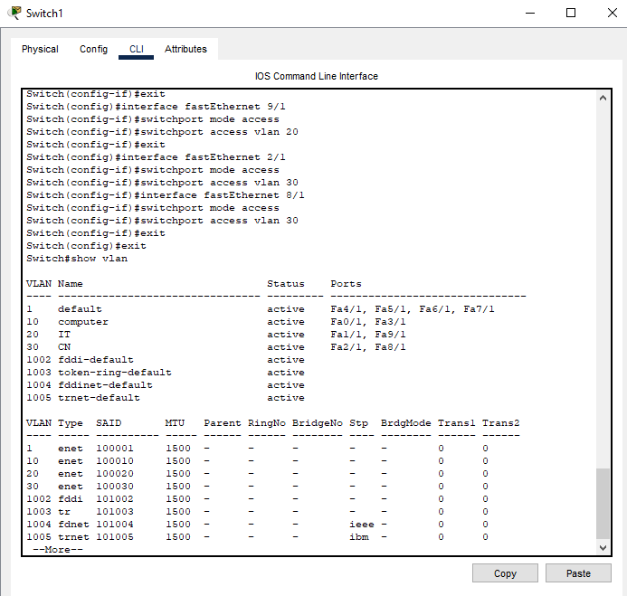

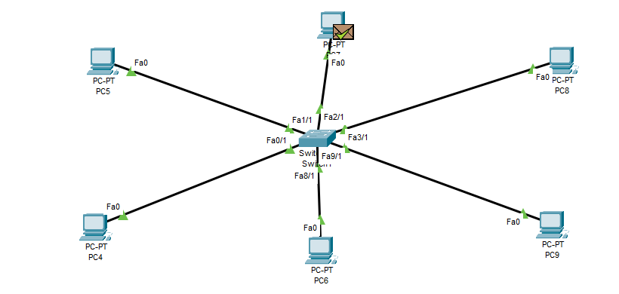

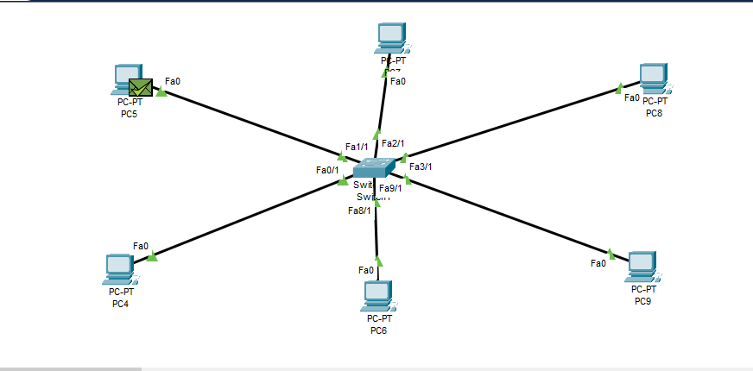

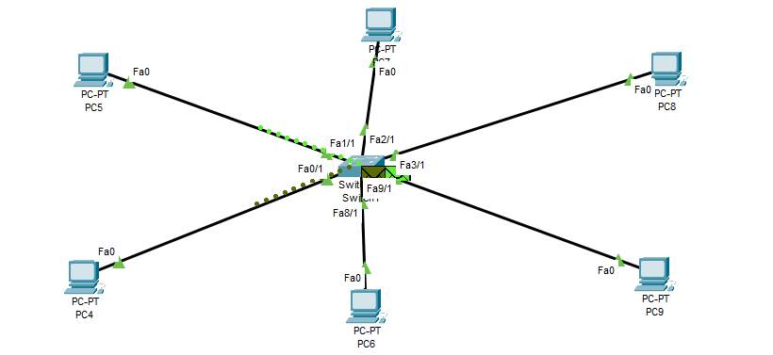

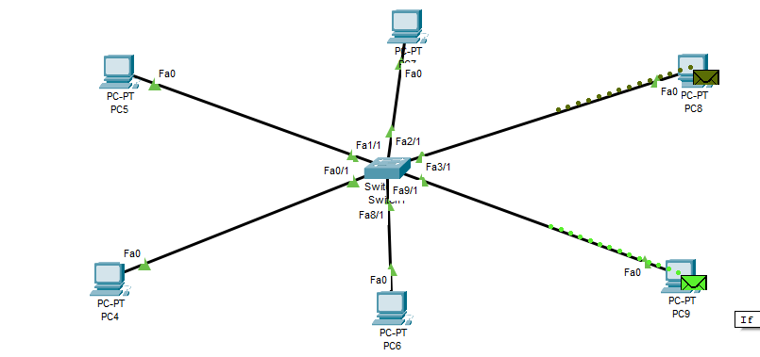

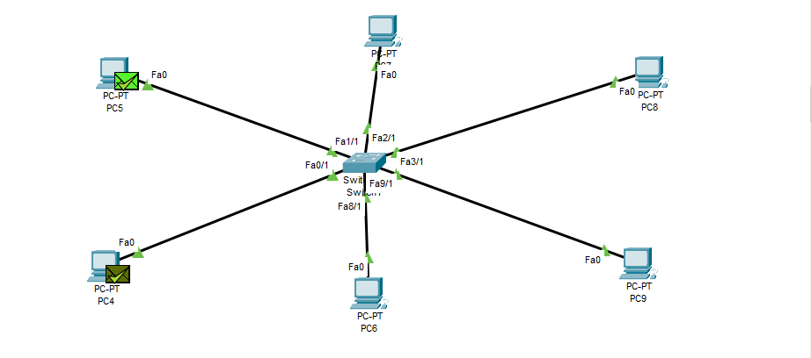

**CONCLUSION:**

Learned VLAN using cisco packet tracer.

**Date: 21/10/24 Signature of faculty in-charge**